

Computer Vision

Section-1

Submitted to faculty: Professor Mehul Raval

Date of Submission: 20-04-2022

Student Details

Computer Vision-Super Image Resolution

| Roll No. | Name of the Student | Name of the Program |
| --- | --- | --- |
| AU1940109 | Jap Purohit | CV |
| AU1940034 | Varun Deliwala | CV |
| AU1940267 | Sahil Miskeen | CV |
| AU1940142 | Shail Patel | CV |

**Tasks performed this week:**

We built the gan model using SRRESNET(generator) and setting the perceptual loss as MSE.

**Outcomes:**

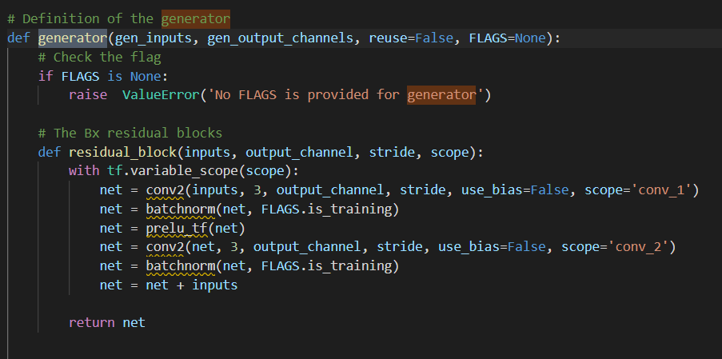

The output of the image is shown below

**Low Resolution Image**

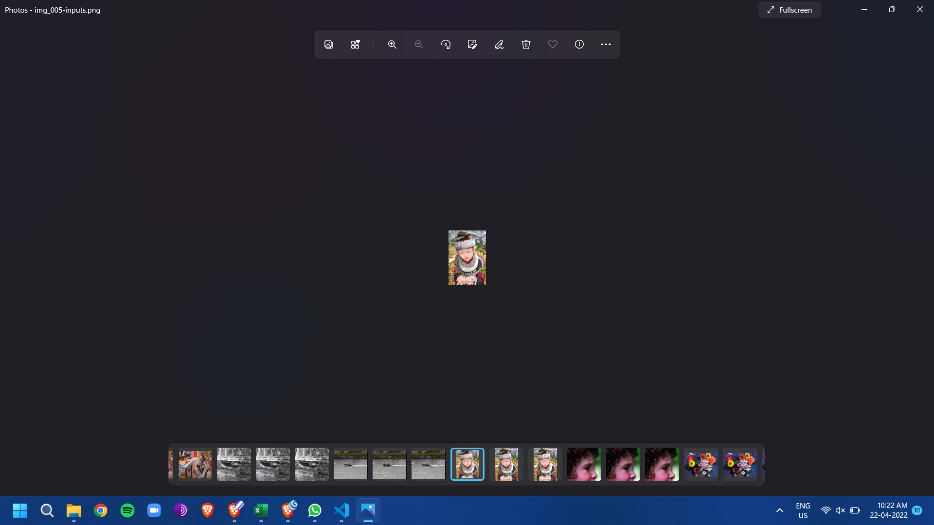

**High Resolution Image Model Predicted (200 * 200 * 3)**



**The model is able to scale the low resolution image.**

**As visible the output is much better than the one achieved by sub pixel convolution.**